
National Forensic Sciences University, Gandhinagar
School of Cyber Security and Digital Forensics

Assignment 5: Docker Monitoring & Visualization using Grafana & Prometheus

Name: Aastha Thakker
Roll No. 250103002004
Sem: 3
Subject: Cloud Security Forensics
Course: MSc Cyber Security

Batch: 2025 -2027

Docker Monitoring & Visualization using Prometheus & Grafana
Reference: https://last9.io/blog/docker-monitoring-with-prometheus-a-step-by-step-guide/
Aim: Set up container and host monitoring for Docker using Prometheus as the metrics collector and Grafana for visualization, following the referenced guide.
1. Setup
Install docker-compose: sudo apt-get install docker-compose
Create 2 files, docker-compose.yml and prometheus.yml

2. Docker Compose Configuration
docker-compose.yml defines three services: Prometheus (the metrics server, port 9090), cAdvisor (collects per-container metrics, port 8080), and Node Exporter (collects host-level metrics, port 9100), along with a volume for persisting Prometheus data.
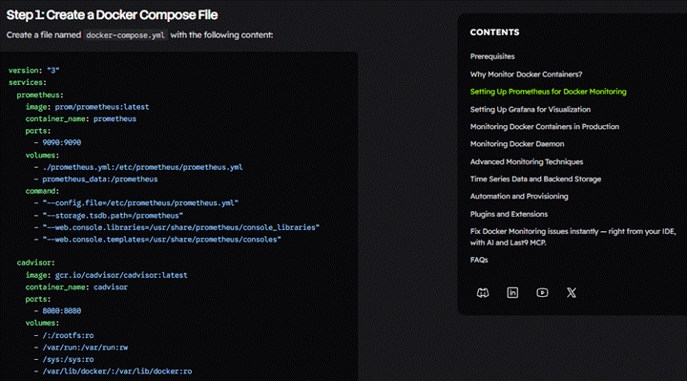
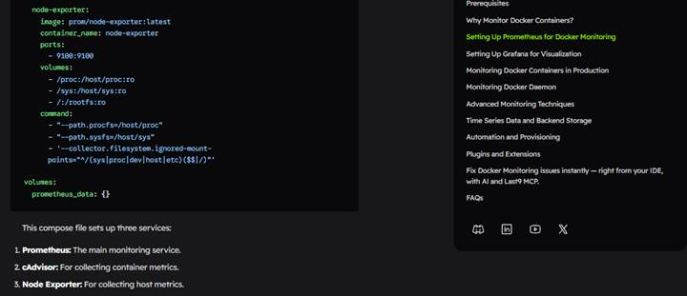
3. Prometheus Configuration
prometheus.yml sets a 15-second scrape interval and defines three scrape jobs; prometheus, cadvisor, and node-exporter, telling Prometheus which endpoints to pull metrics from.
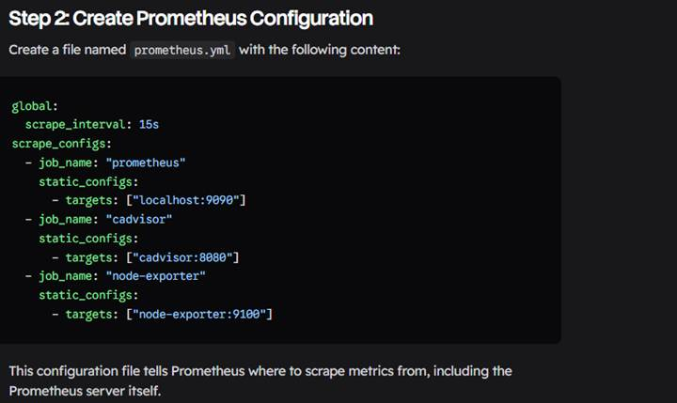
4. Starting the Containers
sudo docker-compose up -d, pulled the required images and started all containers.
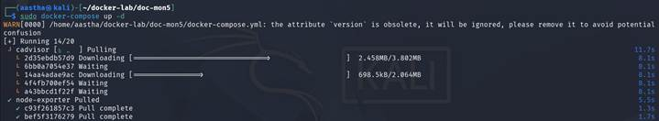
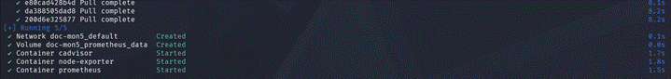
5. Connecting Grafana to Prometheus
In Grafana (localhost:3000), Prometheus was added as a data source using the internal URL http://prometheus:9090, allowing Grafana to query the metrics Prometheus collects.
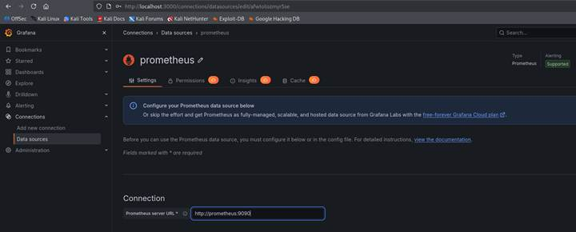
6. Importing a Monitoring Dashboard
A pre-built community dashboard ('Docker and system monitoring') was imported from Grafana.com and linked to the Prometheus data source, to visualize container and host metrics without building panels manually, as per the guide.
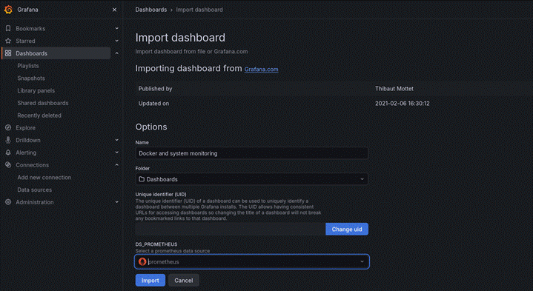
7. Dashboard Data 16310
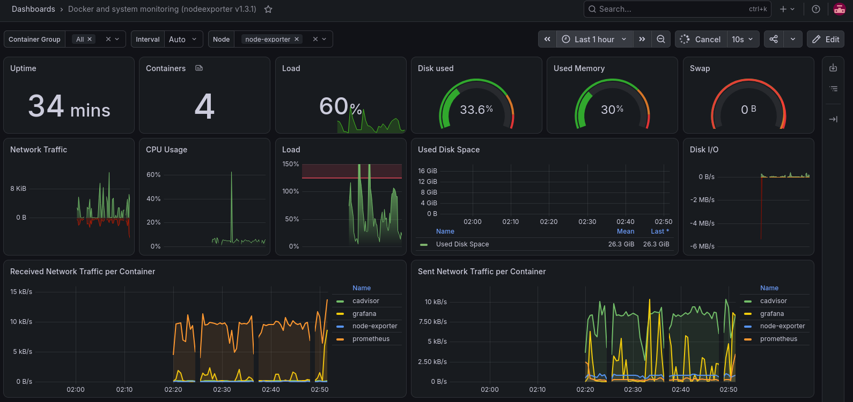
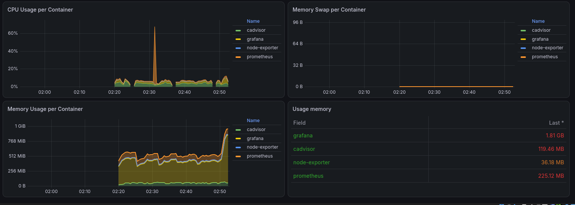

Some additional changes.
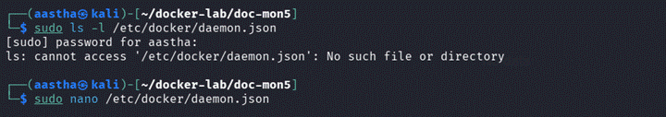
The file was edited to enable Docker's built-in metrics API by adding metrics-addr and enabling the experimental flag, exposing daemon metrics on port 9323.
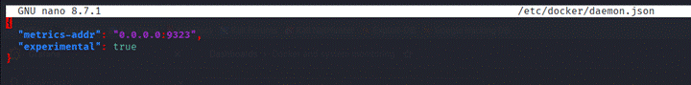
Docker was restarted for the change to take effect, and the service status confirms it is active and that the metrics API is now listening on port 9323.
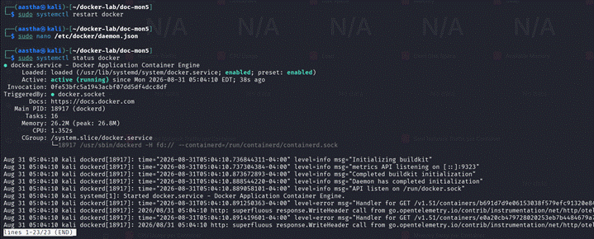
8. Verifying All Containers Are Running
The Prometheus container had exited earlier and was restarted with docker-compose up -d prometheus. A final docker ps confirms all four containers; Grafana, cAdvisor, Node Exporter, and Prometheus are up.
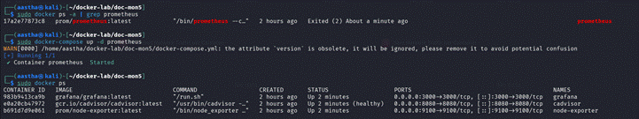
9. Verifying Metrics in Prometheus
The Prometheus Query UI (port 9090) confirms the server is reachable and ready to query collected metrics.
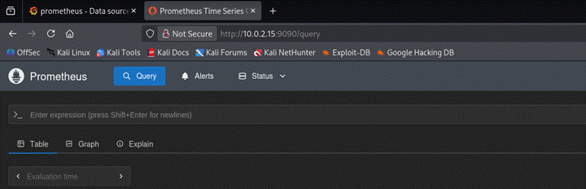
10. Final Dashboard: CPU and Memory Utilization
A custom Grafana dashboard was built showing live data across four panels: Docker CPU Usage (per-container CPU % for cadvisor, grafana, node-exporter, prometheus), Container Memory Usage (per-container memory over time), Host CPU Usage (overall host CPU load), and Host Memory Usage (overall host memory consumption). The graphs confirm metrics are flowing correctly from cAdvisor and Node Exporter through Prometheus into Grafana.
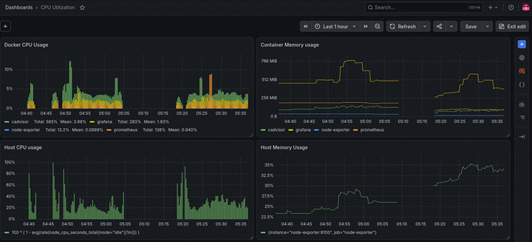
Customization setting was done for showing percentage, graph and colours through edit.
Purpose | Dashboard
Docker + containers + host | 16310
Detailed container monitoring | 21743
Host CPU/RAM/Disk/Network | 17041
